2023 Vendor Contract
Chairperson: Hannah Vehrs (228) 209-3860

CATEGORIES AND PAYMENT

FOOD BOOTH: Fee $150.00. This includes any type of food that will not compete with the fair board food stand, carnival or cattlemen association including but not limited to fish sandwich, hot dogs, French fries, hamburgers, cheeseburgers, bbq pork, beef brisket, rib eye sandwich, funnel cake, cotton candy, cheese balls, nachos, and pretzels.

NOVELTY FOOD BOOTH: Booth fee $150.00. This would include but not limited to ice cream, novelty drinks, etc. Not to compete with the carnival food booth.

NOVELTY BOOTH: Booth fee $100.00. The following items may NOT be sold during the fair. Any form of fireworks, popping, or exploding devices, knives, or anything unlawful. Other items may be determined by the fair board as offensive or dangerous. You will be asked to return them to your vehicle.

BUSINESS DISPLAY: Business in Crawford County fee $50.00 out of Crawford County $50.00. This is for information only. A business may take orders and deliver after the fair.
LARGE BUSINESS ITEMS: Must accommodate the depth required. Additional space may be purchased as mentioned above in general rules.

NON-PROFIT ADULT ORGANIZATION/DISPLAY ONLY: Booth fee $50.00 Display for public information only, and is not available for commercial vendors. Informational literature, advertising pens, calendars, note pads, etc. may be given away. SALES OF ITEMS ARE STRICTLY PROHIBITED.

NON-PROFIT YOUTH ORGANIZATIONS/DISPLAY ONLY: Booth fee is $25.00. CCF will determine what is allowed on an individual basis.

DUNKING BOOTH: Booth fee $50.00. A $500,000 liability insurance policy endorsing the CCF as the insured must be purchased by the vendor. A copy must accompany the form.

ANIMAL, VEHICLES, EQUIPMENT, MECHANICAL RIDES: Booth fee $200.00. Charges include adequate booth space. Each ride requires individual agreement. Each ride vendor agrees to liability insurance to cover ride and endorse the CCF. Must accompany the form.

HOURS
- All concessions shall be open for business and staffed during the entire time the fair is open to the public.
- No business shall be conducted in any place other than your assigned booth space. The hours are as follows:
Tuesday 6PM-10PM
Wednesday 6PM-11PM
Thursday 5PM-11PM
Friday 5PM-12PM
Saturday 12 Noon-12PM
In the event of rain, vendors are expected to open their booths within one hour of the rain ceasing. You may remain open earlier or later as crowd permits. Check schedule for events.

SETUP & DEPARTURES
- Check In - You will receive location of booth space, power hookups, and general information about the fair when you check in at the Caboose.
- Set Up - All concession operators shall be set up on Wednesday unless other arrangements have been made with the chairman. No booth will be allowed to set up after the fair starts each day.
- Restock - All booths should be restocked one hour before the booth opening time.
- Departures - No early break downs on Saturday night. All booths should be broken down by noon on Sunday.

GATE PASSES
Everyone working the booth over the age of 4 will need a pass.
- Season pass - $30
- Daily passes - Tues. -FREE, Wed. -$15, Thurs.- $15, Fri. - $20.00, Sat. -$25.00
No daily passes are available in advance. You may exchange your season pass for an arm band when you set up. Everyone will be required to wear armbands.
GENERAL BOOTH RULES
Spaces will be a 12’X12” space. Booth fees double for an additional 12’x12’ space. Hitches, tie downs, ramps, and extensions must remain in the allotted space.
NOTE: At the discretion of the Crawford County Fair (CCF), certain types of attractions may require an individual contract and/or a certificate of insurance.

TERMS AND CONDITIONS
The Crawford County Fair is a FAMILY EVENT, and vendors should plan their merchandise mix with that in mind. If any merchandise is found to be objectionable to a family audience, vendors will be asked to remove their articles.
TERMINATION RIGHTS
The CCF, through its Concessions Committee, reserves the right to exclude any item or vendor. Termination of operation of any vendor may occur at any time during the fair if items sold or displayed are not of the highest quality as determined by CCF. NO REFUNDS WILL BE GIVEN. Also CCF reserves the right to terminate this agreement at any time if the vendor, in the judgment of CCF, commits any detrimental to the purpose of the fair, fails to cooperate with the representatives of CCF or breaches any of its agreements herein. No refunds will be given if the concessionaire decides to leave early for any reason.
PREMISES
Vendor warrants that the premises shall be left in as good condition as the vendor found them; this includes picking up and disposal of trash at and around your booth.
RAFFLES & DRAWINGS
Any vendor may encourage higher traffic levels at their booth by offering raffles or drawings. Winners may be posted daily.
SECURITY
Although general security will be provided throughout the fair, we suggest you take additional precautions and lock up all unnecessary extension cords, and loose items. The CCF and the City of Cuba will not be held responsible for any damages, loss, or expenses arising out of the activities of CCF.
INDEMNIFICATION
The vendor agrees to indemnify CCF, any of its sponsors, and the City of Cuba against loss resulting from any activity of the vendor during the Crawford County Fair.

- The Crawford County Fair Board will not be responsible to any individual, corporation or association for any losses by fire, theft, damage or personal injury sustained by anyone through the negligence of any person or group of persons, exhibits or exhibitors. Any behavior deemed improper can result in removal from the fairgrounds by the authorities or fair board officers.

Company Name: ____________________________________________ Phone: _________________
Name: ____________________________________________ E-mail: ____________________________
Street Address: ________________________________________________________________________
City, State, Zip Code: _________________________________________________________________

Items to be sold/displayed - First time vendors, please include photos. No substitutions allowed once acceptance is confirmed in writing. May attach a menu.

__________________________________________________________________________________________

Electric - Please provide all information regarding electrical power requirements.

__________________________________________________________________________________________
Category & Fees (Please mark booth category)

- Food Booth
- Novelty Food Booth
- Novelty Booth
- Business Display
- Large Business Item
- Dunking Booth

- Non-Profit Adult Organization/Display Only
- Non-Profit Youth Organization/Display Only
- Animals, Vehicles, Equipment, Mechanical Ride

12’ X 12’ Space Rental Fee: __________________________________
Additional 12’x12’ Space Fee: __________________________________
Season Passes:# _________ @ $30.00 each _______________________

Total Fees __________________________

Make Check or Money Order for the Full Amount Payable to: Crawford County Fair Inc.
NOTE: Personal checks will not be accepted after May 31, 2022.

CONTRACT DUE: MAIL TO: Crawford County Fair Inc.
April 1 PO Box 399
Cuba, MO 65453

I have read and understood all of the terms and agree to abide by the terms in the vendor contract.

Authorized Signature: ______________________________________ Date: __________________

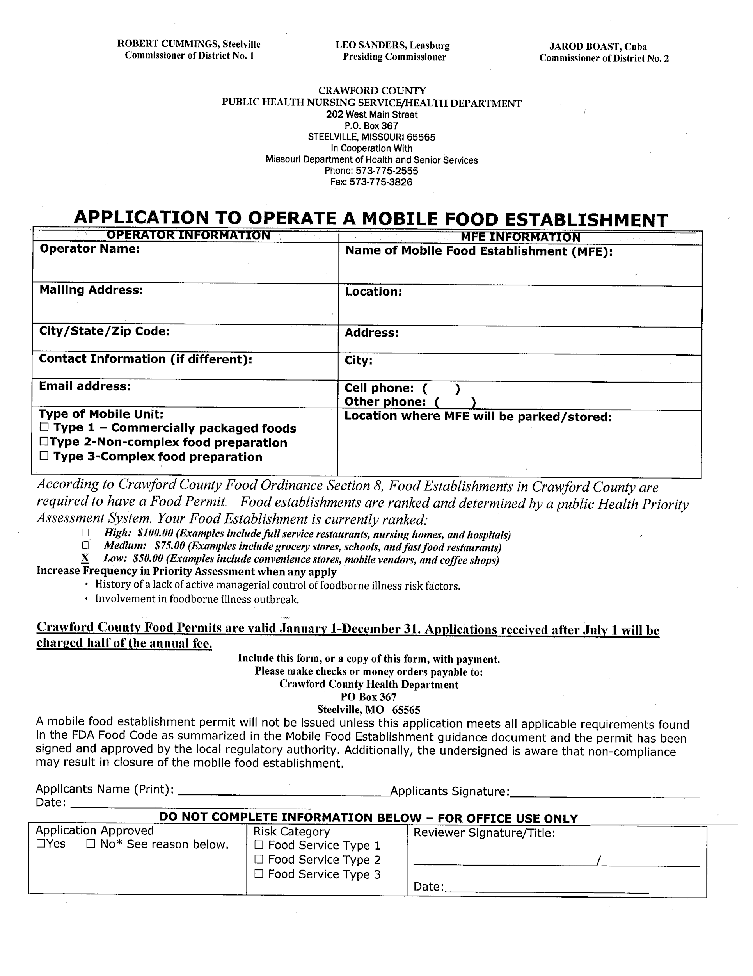
** The Crawford County Department of Health will inspect all food booths before opening. There is an additional $25 licensing fee to be paid to the Health Department. A separate check for $25 payable to Crawford County Health Department and mailed to the address on their form. (This fee is a separate fee from the fair vendor fee.)

